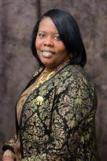

It is an honor to introduce myself as the new Principal of Bayvale Elementary School and to join this extraordinary school community. I can assure you that I share in this school community’s commitment to caring for your children each and every day while providing them with a world-class learning environment.
I arrive at Bayvale Elementary after nearly 26 years as an elementary through college teacher and Principal. I have educated learners in two states and two countries which have provided me with a global vision and a passion for diversity. In addition to my role as an educator and educational leader, I am first and foremost a wife, mother of three, and grandmother of four.
The elementary principalship provides me the chance to work collaboratively with teachers on a daily basis, while also remaining connected to young students learning and growing in the classroom. I firmly believe that every child can excel and that the partnership between home and school builds confidence in students to work to their potential.
To the students of Bayvale Elementary, I cannot wait to meet you all! I hope that you are excited for this coming school year and that you enjoyed your summer break playing and reading tons of books with your family and friends. This year will be epic!
In closing, please know that my door is always open to you. I heartily welcome your conversation and positive input throughout this year. Let us always keep our students as the primary focus of our work. I look forward to celebrating our collective successes during the 2023-2024 school year.

Sincerely,
Principal Shaunta Taylor
Meet Principal Taylor…

